**PROJECT REPORT#1**

**MICROPROCESSOR AND MICROCONTROLLERS**

Submitted by:

AMINA QADEER & HINA HAQ

CE-42-A

********************************************************************************************************************************************

**PROJECT TITLE:**

**DIGITAL THERMOMETER**

********************************************************************************************************************************************

ABSTRACT REPORT:

* Our project is simple use of A PIC-18F452 microcontroller and DS18B20 to operate a digital thermometer.
* Generally, the LM35 temperature sensor is used with microcontrollers to measure the temperature because it is cheap and easily available. But LM35 gives analog values and we need to convert them into digital using ADC (Analog to Digital Converter). But today we are using **DS18B20 temperature sensor** in which we don’t need an ADC conversion to get the temperature. Here we will use **PIC Microcontroller with DS18B20 to measure the Temperature**.

DS18B20 is an excellent sensor to accurately sense the temperature. This sensor provide 9bit to 12bit resolution on temperature sensing. This sensor communicates with only one wire and does not need any ADC to acquire analog temperatures and converting them in digitally.The DS18B20 sensor's cycle begins with a reset, so we will do that and watch for the presence pulse. We shall write on the scratchpad and make the sensor's resolution 12 bits. Since its one of specification of DS18B20 that it is Programmable Resolution from 9 Bits to 12 Bits and further Send the temperature conversion command to read the temperature to read temperature from scratchpad.

This project shall also verify the temperature value to see if it is positive or negative. Output displays on 16x2 LCD hence detecting for a +/-.20 degree Celsius change in the temperature.

*******************************************************************************************************************************************

**COMPONENTS REQUIRED:**

**1.PIC18F452**  2. **Crystal oscillator 4Mz**

**3.DS18B20 or LM35 (Temperature sensor)**  4. **Capacitors 22pf**

**5.Potentiometer 10k**  6. **Resister 1k**

**7.Wires**  8. **LCD 16X2**

**********************************************************************************************************************************************************

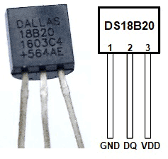

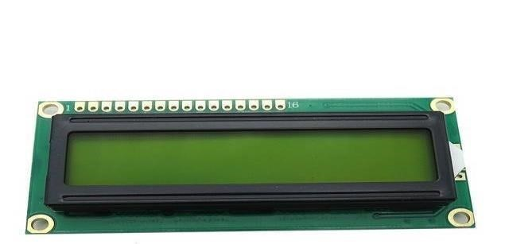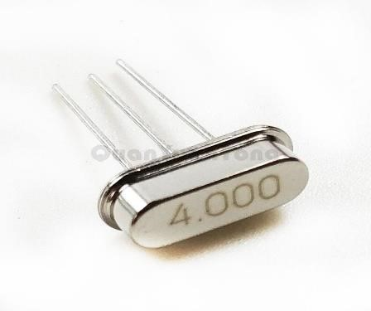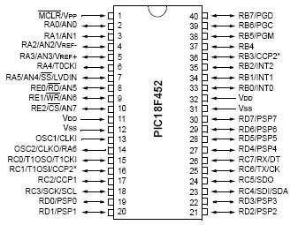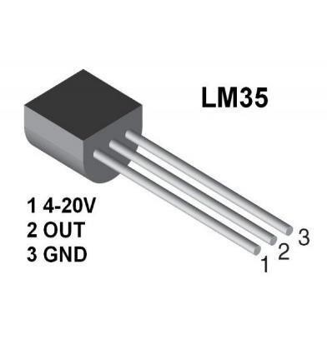

**Equipment details:**

**PIC18F452:**

PIC18F452 is an 8-bit microcontroller with 10 MIPS, CMPS, FLASH-based microcontroller that has 34 I/O pins out of 40 Pin packages. It is a powerful microcontroller with one 8-bit and three 16-bit timers, 8-Channels 10-bit Analog-digital converter, and I2C, SPI, USART peripheral. It is a Low power microcontroller unit that consumes about less than 0.2 uA standby current and 1.6mA normal current during 5V and 4 Mhz operations.

**DS18B20** Or **LM35 (Temperature sensor)**

DS18B20 is an excellent sensor to accurately sense the temperature. This sensor provide 9bit to 12bit resolution on temperature sensing. This sensor communicates with only one wire and does not need any ADC to acquire analog temperatures and converting them in digitally.

The specification of the sensor is:-

* Measures Temperatures from -55°C to +125°C (-67°F to +257°F)
* ±0.5°C Accuracy from -10°C to +85°C
* Programmable Resolution from 9 Bits to 12 Bits
* No External Components Required
* The sensor use 1-Wire® Interface

LM35 is a temperature sensor that outputs an analog signal which is proportional to the instantaneous temperature. The output voltage can easily be interpreted to obtain a temperature reading in

Celsius. The advantage of lm35 over thermistor is it does not require any external calibration.

**LM35** is a temperature sensor that outputs an analog signal which is proportional to the instantaneous temperature. The output voltage can easily be interpreted to obtain a temperature reading in

Celsius. The advantage of lm35 over thermistor is it does not require any external calibration.

**LCD 16X2:**

A 16x2 LCD means it can display 16 characters per line and there are 2 such lines. In this LCD each character is displayed in 5x7 pixel matrix. The 16 x 2 intelligent alphanumeric dot matrix display is capable of displaying 224 different characters and symbols. This LCD has two registers, namely, Command and Data.

**Crystal oscillator:**

A crystal oscillator is an electronic oscillator circuit that uses the mechanical resonance of a vibrating crystal of piezoelectric material to create an electrical signal with a precise frequency. The oscillator we used in this circuit is 4mhz frequency which means that it will give a signal after 0.25us. It is connected externally to the microcontroller.

**EXPECTED RESULTS:**

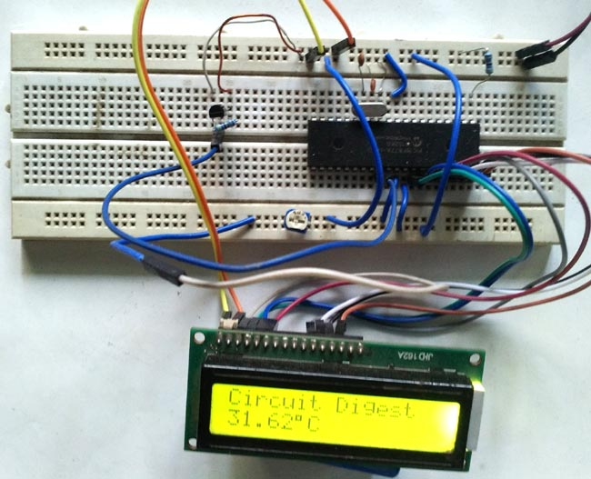

*************************************************************************************

**THE END**